### Valentine's Day Cupid Love Box

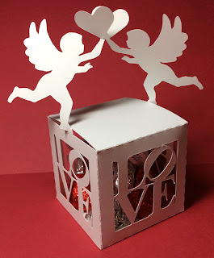

I love this new version of my Love box. The Cupid's hearts are intertwined at the bottom of the heart. The hearts are held together without glue or tape. The box has a top closure and it can hold four Hershey kisses. It is a lovely box to give to your sweetheart.

❤️Happy Valentine's Day! ❤️